Sunny chavda

HTML

Assignment 1

1. Are the HTML tags and elements the same thing?

HTML tag holds the HTML element and the HTML element holds the content. HTML Tags are the starting and ending pars of an HTML element. They begin with < symbol and end with > symbol. Whatever written inside <and> are called tags.HTML element consist of both the opening and closing tags as well as What’s inside those tags. It normally consist of some structure that’s used to define the respective tags.



1. What are tags and attributes in HTML?

|  |  |
| --- | --- |
| TAGS | ATTRIBUTE |
| Hold the HTML element | Attribute provides additional information |
| It starts with < and ends with > | Attribute are specified in opening tags |
| Tags are the way of denoting an HTML elements. | Way of defining the characteristics of an HTML elements. Consists of name and value |
| Eg <h1></h1> | <img src=””> |

1. What are void elements in HTML? With Example.

Void elements are the self-closing tags , It doesn’t have any contents in it .void elements are used to add structure and functionality to web page.

Example: br , hr , img , input , area , base , link , meta, source.

1. What are HTML Entities? With Example.

HTML entities are special codes used in HTML (Hypertext Markup Language) to represent reserved characters, symbols, or special characters that have a specific meaning in HTML. These entities are used to display characters that might otherwise be interpreted as HTML code or have special significance in the markup language.

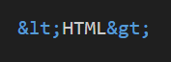

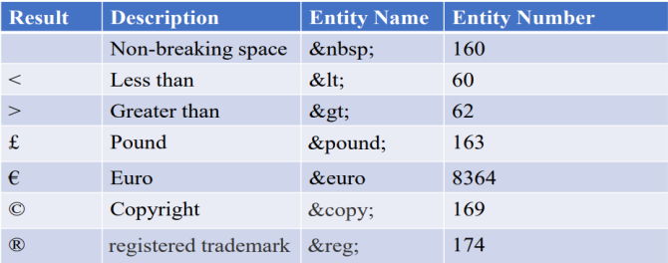

1. What are different types of lists in HTML? With Example.

Lists are used to group together related pieces of information. Lists are easy to read. There are four list types in HTML:

Unordered list

Ordered list

Description list

Nested list

**Unordered list:-**

• An unordered list is a collection of related items that have no sequence.

• Unordered list is created by <ul> tag.

• Each list item starts with the <li> tag.

• Each item in the list is marked with a bullet.

**type attribute:**

• You can use type attribute for <ul> tag to specify the type of bullet you like.

• By default, it is a disc. Following are the possible options-

**<ul type = "square">**

**<ul type = "disc">**

**<ul type = "circle">**

Example:-

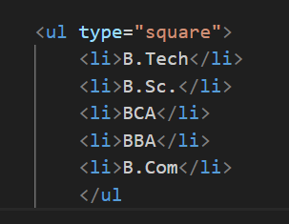

**Ordered list:-**

• If you are required to put your items in a numbered list instead of bulleted, then HTML

ordered list will be used.

• This list is created by using <ol> tag.

• The numbering starts at one and is incremented by one for each successive ordered list

element tagged with <li>.

**type Attribute:-**

• By default, it is a number. Following are the possible options.

**<ol type=“1”>**

**<ol type=“A”>**

**<ol type=“a”>**

**<ol type=“I”>**

**<ol type=“i”>**

**start Attribute:-**

• We can use start attribute for <ol> tag to specify the starting point of numbering we need.

• Following are the possible options −

**<ol type = "1" start = "4"> - Numbers starts with 4.**

**<ol type = "I" start = "4"> - Numbers starts with IV.**

**Example:-**

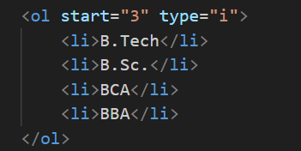

**Definition(description) List:-**

• HTML also supports description lists.

• A definition list is a list of terms, with a description of each term.

• The definition list is very appropriate when you want to present glossary, list of terms or

other name-value list.

• The HTML definition list contains following three tags:

**<dl> tag defines the start of the list.**

**<dt> tag defines a term.**

**<dd> tag defines the term definition (description).**

**Example:-**

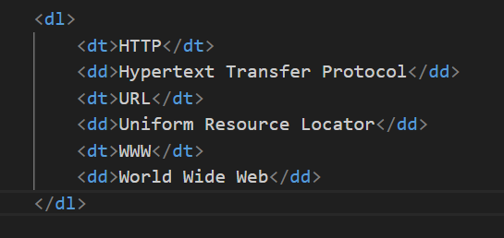

1. What is the ‘class’ attribute in HTML? With Example.

Class attribute specify one or more class names for an element. With class attribute we can also define same style for different html elements.

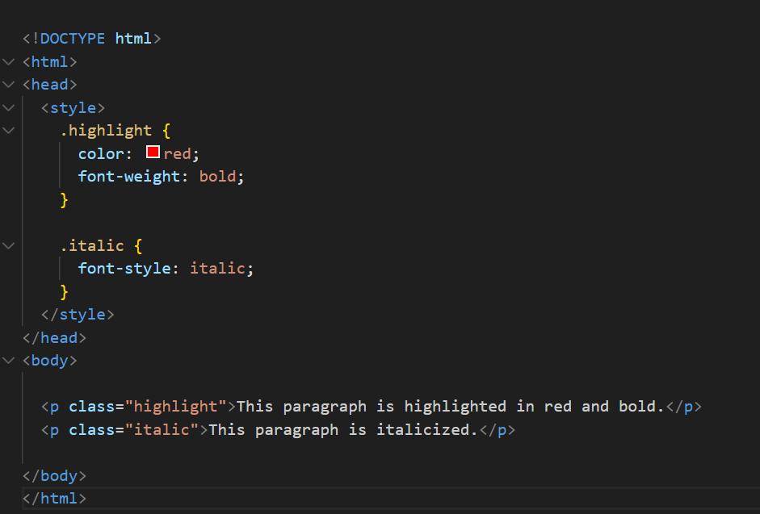

1. What is the difference between the ‘id’ attribute and the ‘class’ attribute of HTML elements? With Example.

**class Attribute:** The class attribute is used to group multiple HTML elements together so that they can be styled collectively using CSS. Elements with the same class share the same styling.

**id Attribute:** The id attribute is used to uniquely identify a single HTML element on a page. Each id must be unique within the HTML document.

|  |  |
| --- | --- |
| Class attribute | ID Attribute |
| Can be used for multiple elements | Unique to each element on the page |
| Define using class attribute | Define using ID attribute |
| Preceded by “.” In css selector | Preceded by “#” in ID selector |
| Class attribute can have same name for multiple elements in HTML | There can only be one element with specific id name |

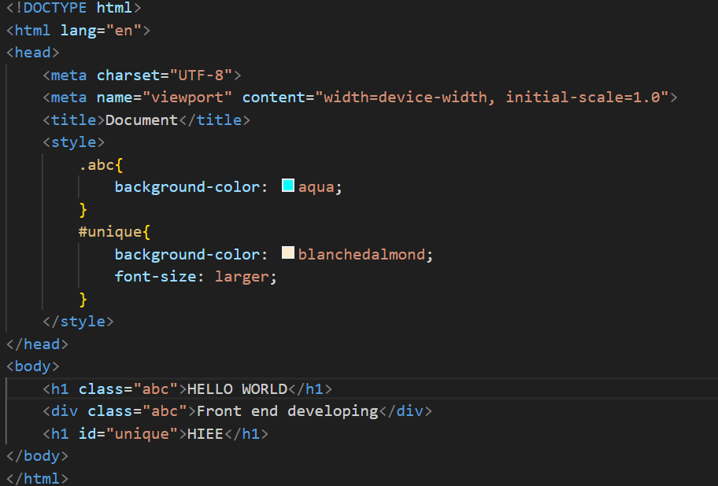

1. What are the various formatting tags in HTML?

HTML Formatting is a process of arranging contents for better look. HTML formatting is used to design the page content part. HTML provides us ability to format contents without using CSS. There are many formatting tags in HTML which are listed below.

Examle:

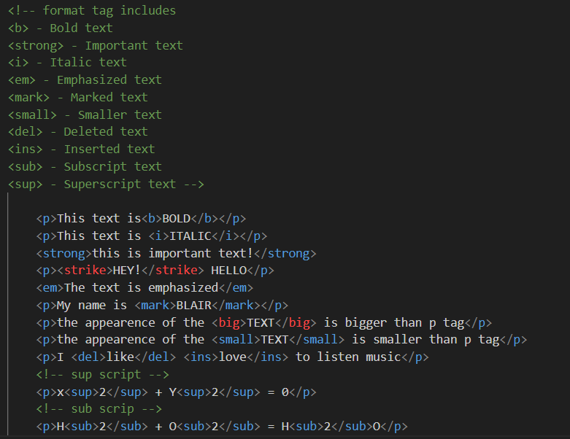

1. How is Cell Padding different from Cell Spacing? With Example.

**Cellpadding** is the space between cell borders and content within the cell. **By default padding is set to 0.**

**Cellspacing** is the space between each cell. **By default the space is set to 2 pixels**.

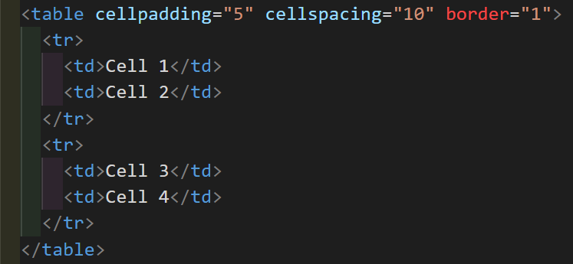

1. How can we club two or more rows or columns into a single row or column in an HTML

table? With Example.

We the help of **ROWSPAN** and **COLSPAN** attribute we can merge two or more rows or columns.The rowspan and colspan are the attributes of tag.

We will use colspan attribute if you want to merge two or more columns into a single column. Similar way you will use rowspan if you want to merge two or more rows into a single row.

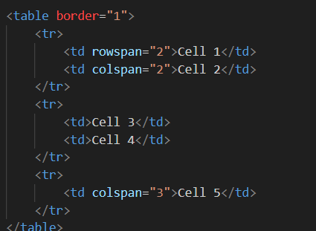

1. What is the difference between a block-level element and an inline element?

**Block elements** typically start on a new line and take up the full width available, extending from the left to the right edge of their containing element or the viewport.

They create a "block" or a "box" in the layout.

Example:



**Inline elements** do not start on a new line; they flow within the content and only take up as much width as necessary.

They do not create new blocks but rather flow alongside the surrounding content.

Example:



1. How to create a Hyperlink in HTML? With Example.

We can create Hyperlink in html by using anchor tag. We can click on a link and jump to another document. The HTML tag defines a hyperlink. The most important attribute of the element is the href attribute, which indicates the link's destination.

By default, links will appear as follows in all browsers:

**An unvisited link is underlined and blue**

**A visited link is underlined and purple**

**An active link is underlined and red**

It has the following syntax:



1. What is the use of an iframe tag? With Example.

The tag specifies an inline frame. It is used to embed another document within current HTML document. Using iframe we can embed any video or audio type document in web page.

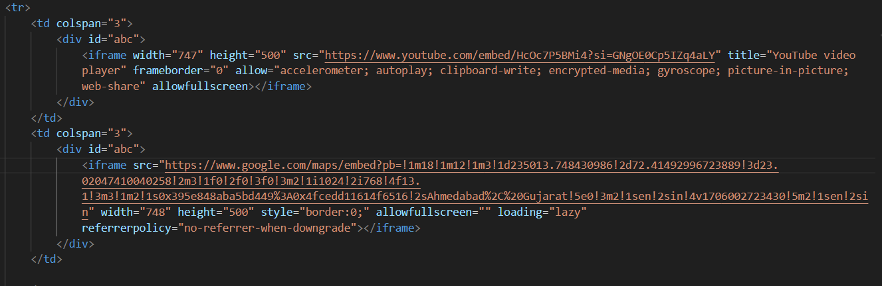

1. What is the use of a span tag? Explain with example?

Span tag is use to wrap sections of text for styling purposes or to add attributes to a section of text without creating a new line of content.

Example:

**<p>This is a <span style="color: blue; font-weight: bold;">blue and bold</span> text.</p>**

**Screenshot 2024-02-12 171851.png**

1. How to insert a picture into a background image of a web page? With Example.

To add a background image on an HTML element, use the HTML style attribute

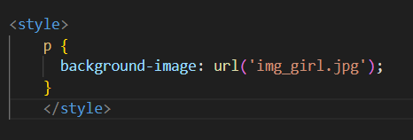

1. How are active links different from normal links?

**Normal link**

A "normal link" usually refers to a standard hyperlink on a webpage that, when clicked, directs the user to another page or resource. These are the basic links that form the foundation of navigation on the internet.



**Active links**

Active links refer to links that have a specific behavior or are currently in use.

In some cases, "active links" might be associated with links that are currently functional and accessible, as opposed to broken or inactive links.

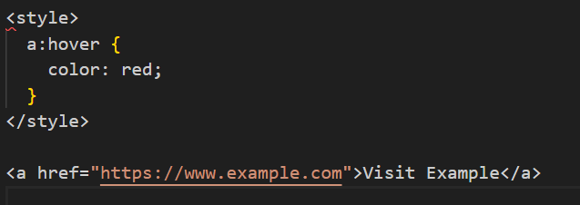

1. What are the different tags to separate sections of text?

Some commonly used HTML tags are

Br, pre, hr , div, p , blockquote

**Br tag**

The <br> tag inserts a single line break. It is useful for writing addresses or poems.

The <br> tag is an empty tag which means that it has no end tag.

**Pre tag**

The <pre> tag preserves whitespace and line breaks, displaying text exactly as it appears in the HTML code**.**

**P tag**

Use the <p> tag to define paragraphs. It adds space above and below the enclosed text.

1. What is SVG?

SVG is a W3 consortium and it stands for Scalable Vector Graphics. SVG is used to define vector-based graphics for the Web. SVG defines graphics in XML format Each element and attribute in SVG files can be animated SVG is a W3C recommendation. SVG integrates with other standards, such as CSS, DOM, XSL and JavaScript



1. What is difference between HTML and XHTML?

XHTML is an older, stricter version of HTML that follows XML rules. HTML5 is the latest and more flexible version, bringing in new features for better multimedia and web applications. HTML5 is simpler to use, while XHTML demands strict adherence to XML standards.

|  |  |
| --- | --- |
| HTML | XHTML |
| Hypertext Markup Language | Extensible Hypertext Markup Language |
| It is non case Sensitive | It is Case Sensitive |
| Extension: .html , .htm | .xml , .htm , .html , .xhtml , xht |
| Developed by Tim Berners Lee | Recommended by W3C |
| It uses format which one is similar to document formars | It uses the markup Language |

1. What are logical and physical tags in HTML?

**Logical Tags:**

HTML is primarily concerned with the logical structure and content of a web page.

It defines the elements on a page, such as headings, paragraphs, lists, images, links, etc.

It establishes the relationships between different parts of the content.

Logical Tags are used in HTML to display the text according to the logical styles.

Example: abbr , blockquote , address , ins , del , cite , code

**Physical Tags:**

-CSS, on the other hand, is used to control the presentation and styling of the HTML elements.

-It defines how the content should be displayed, specifying details like colors, fonts, spacing, layout, etc.

-CSS allows for the separation of design concerns from the actual content, making it easier to maintain and update styles. tc.

- While these tags were widely used in older versions of HTML, they are now considered outdated and are typically avoided in modern web development.

Ex.<b>,<i>,<font>,<center>